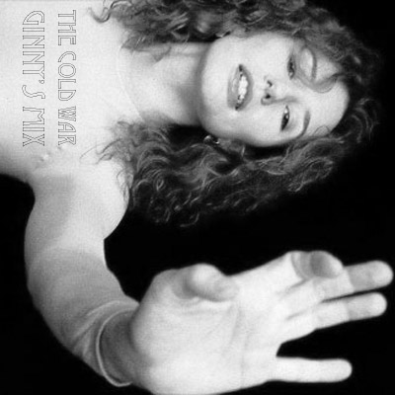

Cold War Mix I – 7.2.2008

- Cold War: Mad World, Michael Andrews & Gary Jules
“And I find it kind of funny, I find it kind of sad,
The dreams in which I’m dying are the best I ever had….”

- Harry: Cliquot, Beirut
“What melody will bring my lover from his bed?
What melody will see him in my arms again?”

- Ginny: Jenny, Stellastarr*
“Jenny’s coming after you
You’ll keep shining on, shining on
But you’ll never know where your place will be.…”

- Diary: Uninvited, Alanis Morissette
“Like any hot-blooded woman I simply wanted an object to crave
But you, you’re not allowed, you’re uninvited.…”

- Dinner and Dancing: Mother, Tori Amos
“Dripping with blood and with time and with your advice
Poison me against the moon….”

- Remus: Too Tired, DeVotchKa
“Regretful of the past, you know these things won’t last
A lifetime gone so fast, these things will never last ….”

- Lucius: Big Brat, Phantom Planet
“It was all his fault, introduced me to know-it-all and the cannibal….”

- Narcissa: Someone To Die For, Belly
“Poor thing, poor thing, do you have a sister?
Would you lay your body down on the tracks for her?
Step one tiptoe in hell for her?”

- Draco: Poor Little Rich Boy, Regina Spektor
“Poor little rich boy, all the couples have gone,
You wish that they hadn’t, you don’t wanna be alone….”

- Tom: Trigger Happy Jack, Poe
“But he underestimates my mind, I know he’s messing with my head
My only weakness is I can’t believe the guy could be entirely dead
Can’t talk to a psycho like a normal human being….”

- Ill-Advised Liaison: The Age of the Understatement, Last Shadow Puppets
“Before the attraction ferments, kiss me properly and pull me apart….”

- Noble and Most Ancient House of Black: Knights of Cydonia, Muse
“No one’s gonna take me alive, the time has come to make things right
You and I must fight for our rights, you and I must fight to survive….’”

- Colour-Changed Chickens: Know Your Chicken, Cibo Matto
“One was magenta the other was blue….”

- Umbridge and Marietta: Airport Song, Guster
“I’m here seeking only what I need, in your mind is where I’ll plant the seed
Let me keep you in this place, you’ll be better off this way…”

- Life Under The Ministry: The Fox, Nada Surf
“We’re in a different war with ourselves, and with some of you
So many things that can’t be true….”

- The Order: Harrowdown Hill, Thom Yorke
“I’m coming home to make it all right so dry your eyes
We think the same things at the same time
We just can’t do anything about it….”

- Hermione: (nice dream), Nickel Creek
“They dug me my very own garden, gave me sunshine, made me happy
(Nice dream)…”

- Mi and Neville: No Surprises, Radiohead
“You look so tired-unhappy, bring down the government
They don’t, they don’t speak for us….”

- Old Magic: Love Is Stronger Than Death, The The
“How could you believe that the life within the seed
That grew arms that reached, and a heart that beat,
And lips that smiled and eyes that cried
Could ever die?”

